Group 7: Hilda Hermunen, Veera Ruotsalainen, Patrick Scott

Sprint 6 Review

Scrum Master: Patrick Scott

Trello Board Status

Trello board for Sprint 6 included code review analysis and code clean up.

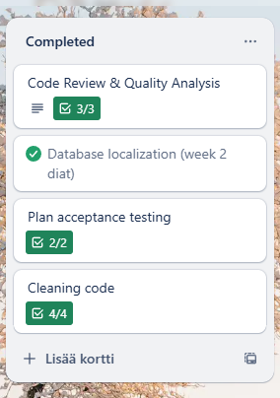

Figure 1: A screenshot of teams Trello board’s Completed table from Sprint 6.

As shown in Figure 1, the team achieved the goals set for Sprint 6. Database localization was completed by creating a setting table in the database, that saves the users language setting. The team made two separate documents for acceptance plan and documenting code review and quality analysis using SonarQube and PMD. The quality analysis tools proved to be useful in cleaning and improving code quality. There was also refactoring done manually.

There are four completed tasks in the backlog. Acceptance test and code quality review documents are in the projects Github repository. No tasks were postponed or discarded.

Time spent by team members

|  |  |  |
| --- | --- | --- |
| **Team member** | **Task assigned** | **Time spent** |
| Veera | Database localization | 2 hours |
| Hilda | Code review & quality analysis (PMD) | 11 hours |
| Patrick | Refactoring | 2 hours |
| Veera | Code review & quality analysis (SonarQube) | 12 hours |

**Obstacles encountered**

Installing code quality analysis tools caused some challenges, but after configurations were corrected, the tools were very useful. There were no other major problems during the Sprint.

Sprint 7 planning

**Tasks**

1. Updating user acceptance preliminary plan to take into account Sprint 7 requirements.
2. Implementing JMeter to the project
3. Creating 10 test cases into the Excel provided by the teacher

* Each team member will come up with three test cases at least

1. Acting as customer representatives and conducting User Acceptance Test: each test case is tested by each team member
2. The results of the User Acceptance Testing are documented the Excel
3. Based on the Excel report, the team will prioritize the bugs and problems utilizing heuristic evaluation
4. Fixing the error that come up in User Acceptance Testing